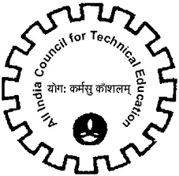
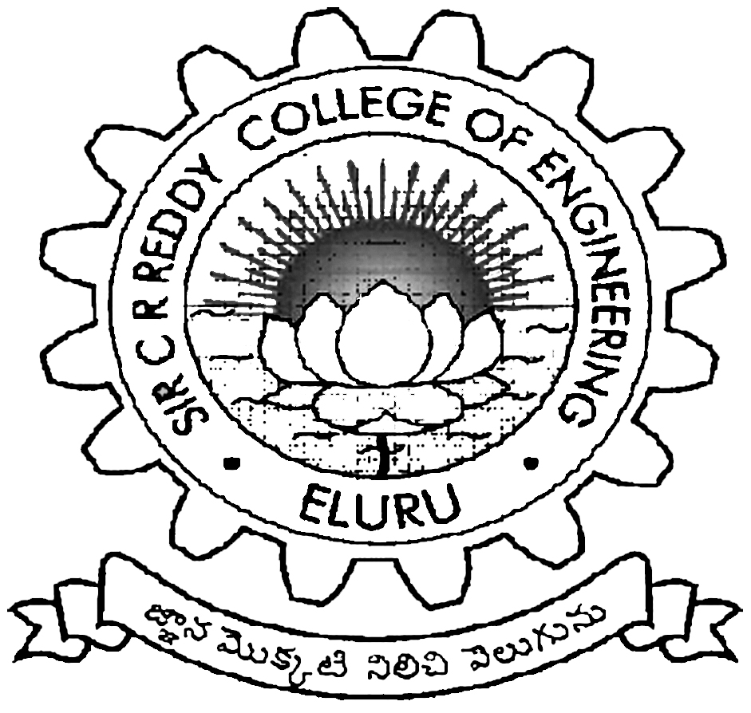
Faculty Development Programme
AICTE sponsored Two Week FDP on
BIO-MEDICAL SIGNAL PROCESSING AND APPLICATIONS
1ST TO 14TH November, 2019
Department of Electronics and Communication Engineering
Sir C R Reddy College of Engineering
Eluru, W. G. Dt, A.P - 534007

REGISTRATION FORM

Name Dr. /Mr./Mrs./Ms.:..……………………………………………………………………..
Designation: …………………………………….……………………………………………..
Educational Qualification:……………………………………………………………………..
Specialization: …………………………………….……………………………………………
Department: …………………………………………..………………………………………..
Institution: ......…………………………………………………………………………………
AICTE Faculty ID No: ………………………….....................................................................

Professional Experience:

Teaching………………….… R&D…………………..…… Industry…………………..……

Mailing Address:
…………………………………………………………………………………………………..
…………………………………………………………………………………………………..
Contact No. …………………………………Mobile .................................................................
Email ID ……………………….……....................................

Payment Details:

DD No. & Date: ..........................................................................................................................
Bank Name & Branch: ................................................................................................................
Accommodation required: YES / NO
(Limited Accommodation is available)

Signature of the Participant with Date

Dr./Mr./Mrs./Ms. ………………………………………………… is sponsored to attend the two-week FDP on “BIO-MEDICAL SIGNAL PROCESSING AND APPLICATIONS” to be held from 1st to 14th November, 2019 at Sir C R Reddy College of Engineering, Eluru.

Place: Signature of the Head of the
Date: Institution with Seal

